REPORT FOR: | Traffic and Road Safety Advisory Panel
Date of Meeting: | 8th February 2018
Subject: | Transport for London Local Transport Fund Schemes Programme 2018/19
Key Decision: | No
Responsible Officer: | Paul Walker – Corporate Director, Community
Portfolio Holder: | Graham Henson - Portfolio Holder for the Environment
Exempt: | No
Decision subject to Call-in: | Yes, following consideration by the  Portfolio Holder
Wards affected: | Stanmore Park, Wealdstone, Harrow Weald, Kenton West, Roxbourne
Enclosures: | Appendix A: Proposed schemes

Section 1 – Summary and Recommendations

This report outlines the proposed programme of traffic schemes to be implemented with the £100,000 Local Transport Fund allocated to the London Borough of Harrow by Transport for London in 2018/19.

Recommendation:
The Panel is requested to consider the contents of this report and Appendix A, and to recommend to the Portfolio Holder those schemes which are a priority to the value of £100,000.

Reason: (For recommendation)
In order for the Council to agree a programme of prioritised local schemes funded by the Local Transport Fund (£100,000) and allocated by Transport for London to the London Borough of Harrow within the 2018/19 financial year.

Section 2 – Report

Introduction

- The highway network has a significant impact on the quality of life of Harrow’s residents and on the viability of Harrow’s businesses. Transport issues are one of the main concerns reported to the Council and this report sets out how local transport issues raised in the borough are being addressed in order to support local residents and businesses.

Options considered

- A range of schemes which have a local transport benefit have been suggested for the Panel to consider. The impacts on corporate priorities, the Transport Local Implementation Plan objectives, equalities and the environment have been provided to assist members with setting their priorities for 2018/19 within the available budget.

Background

- The Transport for London (TfL) award for funding in 2018/19 includes a local transport funding allocation of £100,000. This budget is allocated to boroughs through the Local Implementation Plan (LIP) funding process.

- The local transport fund is to be used by the borough for any local transport schemes they wish to implement. The funds must be used for transport purposes broadly consistent with the Mayor for London’s current Transport Strategy and the Borough’s LIP, but no other criteria apply to this allocation. The purpose of this freedom is to give greater independence to the boroughs. Funds can be used for separate projects or to supplement other TfL LIP funded projects.

- Members have previously determined that the option to use funding to support other LIP projects was not preferred because the fund is too small to have a significant impact and it would be difficult to see these elements as clearly identifiable pieces of work that support local initiatives. The proposed programme therefore focuses on a small number of specific individual projects that are of local interest to members and the public.

Local Transport Fund Programme 2018/19

- A proposed programme of local transport schemes which officers consider to be of benefit to Harrow has been prepared for consideration by the panel. This involved a review of local issues of interest to members, public and other key stakeholders where the schemes will contribute to the Mayoral objectives and Harrow’s LIP objectives. The evaluation of the issues involved consideration of the following factors:

- Cost
- Corporate priorities
- Equalities
- Public support
- Timeframe for completing work (within 2018/19)
- Impact
- Available resources – staff time

- The proposed local transport schemes that could be considered for inclusion in the 2018/19 programme are summarised in the table below.

Ref: | Location | Description of works | Cost Estimate
 | Common Road - school safety scheme | Reduce speed limit from 40 mph to 30 mph in the proximity of Avanti School | £15,000
 | Cecil Road - Extension of existing 20 mph zone | Expand the existing Whitefriars School - 20 mph zone to include Cecil Road | £15,000
 | Eastern Avenue – construct new pedestrian refuge | Provide a pedestrian refuge to assist pedestrians crossing road, notably to access Pinner High School and nearby bus stops | £10,000
 | Rayners Lane / Clitheroe Avenue / Quartz Court - improve access and road safety. | Remove existing ineffective mini roundabout and replace with a change of priority junction. | £20,000
 | Gordon Avenue, Stanmore - Speed reduction scheme | Widen the existing speed cushions to make them more effective | £25,000
 | Graham Road / Claremont Road / Ladysmith Road - walking scheme | Introduce Copenhagen style entry treatments at the junction with High Street  (A409) | £25,000
 | Bessborough Road –pedestrian safety scheme following fatal incident | Widened splitter island and introduce dropped kerbs, tactile paving and waiting restrictions | £10,000
 | Requests for minor road safety measures such as new road markings or traffic signage including speed activated signs and zebrites (Halos around zebra crossing globes) | The council receives many requests each year from local residents and other stakeholders for localised measures to improve road safety.  Not all requests meet our criteria for traffic calming measures this fund would be used where appropriate to address these local requests. | £15,000

- Appendix A to this report contains three tables giving additional information regarding the above schemes for consideration by members:
- Table 1 provides a description of proposed schemes, reasons for their inclusion and their associated costs

- Table 2 provides a list of proposed schemes with their link to corporate priorities, equalities and their environmental impact

- Table 3 shows a list of proposed schemes with their link to Harrow’s transport objectives

- As the panel will note, the implementation of all the above schemes will exceed the £100,000 budget. The panel are therefore requested to recommend to the Portfolio Holder the preferred schemes from the list above, to a value of £100,000, to be taken forward as a part of the 2018/19 TfL programme of works.

Legal implications

- The Traffic Management Act 2004 places an obligation on authorities to ensure the expeditious movement of traffic on their road network. Authorities are required to make arrangements as they consider appropriate for planning and carrying out the action to be taken in performing the duty.

- The programme of schemes highlighted in this report may involve introducing traffic and parking restrictions that require a legal process to be undertaken before they can be physically implemented.

- Subject to statutory consultation requirements, which the Council has complied with, the Council has powers to introduce and change traffic and parking restrictions under the Road Traffic Regulation Act 1984, The Local Authorities Traffic Orders (Procedure) (England and Wales) 1996 and The Traffic Signs Regulations and General Directions 2002.

Financial Implications

- The local transport funding allocation has received approval as a part of the 2018/19 TfL Capital Programme. TfL has allocated 100,000 for the delivery of borough identified schemes and this is an opportunity to deliver local transport schemes which could not have been delivered from the Council’s existing resources. Staff costs for design, management and monitoring of the work will be charged to the TfL budget allocation.

Equalities Implications / Public Sector Equality Duty

- An equality impact assessment (EqIA) has been undertaken on the programme of investment in the Council’s Transport Local Implementation Plan, which includes all of the types of interventions proposed in this report, and no adverse impact on any of the specified equality groups was identified. There are positive impacts on some equalities groups, particularly, women, children and people with mobility difficulties. Benefits are likely to be as follows:

Equalities Group | Benefit
Disability | Reduced risk to pedestrians with mobility impairment or wheelchair users crossing the road due to reduced traffic speed thereby allowing improved accessibility.
Age | Reduced risk to pedestrians crossing the road due to reduced traffic speeds thereby allowing improved accessibility, reduced risk of conflict between motorised vehicles and cycles, particularly for the elderly and young.

Council priorities

- The delivery of the local transport fund schemes accords with the administration’s priorities set out below:
- Making a difference for the vulnerable
- Making a difference for communities
- Making a difference for local businesses
- Making a difference for families

Section 3 - Statutory Officer Clearance

 |  |  | on behalf of the
Name: Jessie Man |  |  | Chief Financial Officer
Date: 23/01/18
 |  |  | on behalf of the
Name: Esayas Kifle |  |  | Monitoring Officer
Date: 25/01/18

Ward Councillors notified: | YES
EqIA carried out:  EqIA cleared by: | NO  An EqIA has been undertaken for the Transport Local Implementation Plan of which this project is a part. A separate EqIA is therefore not necessary

Section 4 - Contact Details and Background Papers

Contact: Barry Philips – Team Leader Tel: 020 8424 1649
e-mail: barry.philips@harrow.gov.uk

Background Papers:

Transport Local Implementation Plan 3, Petitions and Local correspondence
APPENDIX A: PROPOSED SCHEMES

Table 1: Description of proposed schemes, background and costs

 | Scheme | Cost | Reason
 | Common Road – school safety scheme | £15,000 | The main access to Avanti School is located in Common Road which lies within a 40 mph speed limit. At school start and finish times many children are walking near to the school entrance to access the existing bus stops or to continue their journey on foot. The footpaths on both sides of the road are quite narrow and there is no scope to widen them. There is a small traffic island near to the school entrance which is used by parents and children to access the bus stops and to get to and from the school. Traffic speeds are high due to the 40 mph speed limit on this section of Common Road; this does not create a very friendly environment.  The plans to improve safety include reducing the existing speed limit from 40mph to 30 mph on both approaches to the school entrance, erecting school warnings signs and flashing “watch your speed signs”, installing “School Keep Clear” markings and new road markings to highlight the school entrance. The school is committed to producing a School Travel Plan and to continue to work with the council to improve safety within their own grounds and on the public highway.
 | Cecil Road - Extension of existing 20 mph zone | £15,000 | The extension of the Whitefriars School 20 mph zones to include Cecil Road will help to reduce traffic speeds and generally improve road safety for all road users close to the School. The promotion of safe and considerate driving and encouraging road users to adopt appropriate speeds on our roads is key to reduce road traffic collisions and injuries, and to develop safer environments for all road users and to encourage modal shift.
 | Eastern Avenue – pedestrian refuge | £10,000 | This scheme was put forward last year as a potential scheme however members decided not to include the request within the programme of LTF requests. The school continues to campaign for a crossing facility in Eastern Avenue to assist children in this area notably to access Pinner High School.
 | Rayners Lane / Clitheroe Ave / Quartz Court – improve access and road safety. | £20,000 | The current road layout is ineffective, the existing mini roundabout is poorly designed and most drivers ignore it and drive straight over the central dome, this leads to speeding and safety concerns which have been raised by residents, local councillors and the bus operator. The predominant traffic movement, which is on a bus route, is Rayners Lane and Quartz Court. Removing the existing mini roundabout and replacing it with a priority junction at the junction of Clitheroe Ave/ Rayners Lane / Quartz Court would therefore make more sense and would help bus accessibility and improve road safety at junction.
 | Gordon Avenue – widen existing speed cushions | £25,000 | A road safety scheme was introduced in Gordon Avenue some twenty years ago. The scheme involved the introduction of speed cushions which were designed to be 1.6 m wide. Since the scheme was introduced personal injury accidents have reduced to zero. More recently however residents have complained that they are ineffective especially since changes to modern car design and the advent or more 4 x 4 type vehicles with speeds increasing. Traffic surveys have confirmed that the 85%tile speed is around 32 mph this is considered high for a road which is traffic calmed. In order to reduce traffic speeds to a more acceptable level it is proposed to widen the existing speed cushions to 1.8 m which from experience in other parts of the borough would reduce speeds to around 25-27 mph.
 | Graham Road / Claremont Road / Ladysmith Road – Copenhagen style crossings walking scheme  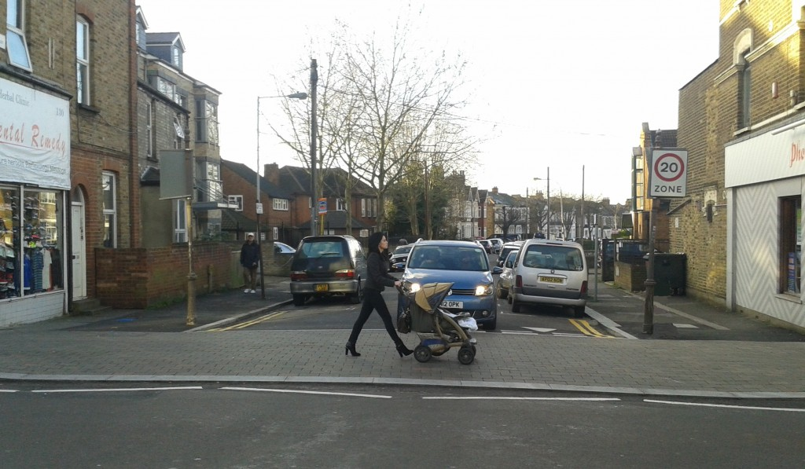 | £25,000 | To help make walking and cycling in the borough easy, safe and enjoyable, we’re proposing a new style of crossing at side road junctions at three junction near schools in Wealdstone called blended 'Copenhagen' crossings. Blended crossings are designed to slow down vehicles when entering or exiting side roads and encourage vehicles to give way to pedestrians crossing the road, reinforcing the rules of the Highway Code. The first crossings of this type in the borough were introduced in Sudbury as part of the Sudbury Village Major Project scheme recently.  The first blended crossings in London were introduced in Clapham in June 2014 .They are however commonplace in mainland Europe, particularly in cities that are considered the best places for walking and cycling. As they are new to the borough and the UK, there will be a period of adjustment as people get used to the new layouts. We appreciate that initially these crossings may confuse pedestrians and drivers, and that they may be seen as unsafe, however the design has been through an extensive evaluation process, including an independent road safety audit process.
 | Bessborough Road –pedestrian safety scheme | £10,000 | Following a fatal incident in May involving a pedestrian crossing close onto the narrow splitter island in Bessborough Road a site meeting was held with the Traffic Police. It was observed that if changes were made to the width of the splitter island to better accommodate pedestrians and parking were removed opposite the island then this would improve pedestrian safety by providing more space and better visibility for pedestrians when crossing this section of Bessborough Road.
 | Requests for minor road safety measures such as new road markings  or signage | £15,000 | The council receives many requests each year from local residents and other stakeholders for localised measures to improve road safety. Not all requests meet our criteria for traffic calming measures such as road humps, chicanes etc. This fund would be used where appropriate to address local traffic concerns.
Table 2: Schemes link to corporate priorities, equalities, and their environmental impact

Ref | Scheme | Cost | Corporate priorities | Equalities | Environmental Impact
 | Common Road – school safety scheme | £15,000 | Making a difference for communities, vulnerable, families. |  | Positive,  Improves road safety and access, reduces congestion
 | Cecil Road - Extension of existing 20 mph zone | £15,000 | Making a difference for communities, vulnerable, families. |  | Positive,  Improves road safety and encourages greater use of walking and cycling
 | Eastern Avenue – pedestrian refuge | £10,000 | Making a difference for communities, vulnerable, families. |  | Positive,  Improves road safety and encourages greater use of walking and cycling
 | Rayners Lane / Clitheroe Ave / Quartz Court – improve access and road safety. | £20,000 | Making a difference for communities, vulnerable, families. |  | Positive,  Improves road safety and encourages greater use of public transport
 | Gordon Avenue – widen existing speed cushions | £25,000 | Making a difference for communities, vulnerable, families. |  | Positive,  Improves road safety and encourages greater use of walking and cycling
 | Graham Road / Claremont Road / Ladysmith Road – Copenhagen style crossings walking scheme | £25,000 | Making a difference for communities, vulnerable, families. |  | Positive,  Improves road safety and encourages greater use of walking and cycling
 | Bessborough Road – pedestrian safety scheme | £10,000 | Making a difference for communities, vulnerable, families. |  | Positive,  Improves road safety and encourages greater use of walking and cycling
 | Requests for minor road safety measures such as new road markings or signage | £15,000 | Making a difference for communities, vulnerable, families. |  | Positive,  Improves road safety and improves the environment.
Equalities impact Positive but low impact benefit,  Positive but medium impact benefit,  Positive but high impact benefit
Table 3: Schemes link to the Local Implementation Plan objectives in accordance with the MTS

Ref | Scheme | Promote healthy and safe travel particularly for pedestrians and cyclists | Reduce CO₂ emissions in Harrow | Reduce the number of motorcycle casualties across the borough | Reduce the number of pedal cycle casualties across the borough | Increase the number of people cycling in the borough | Improve servicing and reduce congestion and make essential car journeys easier | Improve pedestrian walkways to parks, open spaces, towns and public transport | Improve existing highways, and walkways to promote an uptake in cycling
 | Common Road – school safety scheme |  |  |  |  |  |  |  | 
 | Cecil Road - Extension of existing 20 mph zone |  |  |  |  |  |  |  | 
 | Eastern Avenue – walking initiative |  |  |  |  |  |  |  | 
 | Rayners Lane / Clitheroe Ave / Quartz Court – improve access and road safety. |  |  |  |  |  |  |  | 
 | Gordon Avenue – widen existing speed cushions |  |  |  |  |  |  |  | 
 | Graham Road / Claremont Road / Ladysmith Road – Copenhagen style crossings walking scheme |  |  |  |  |  |  |  | 
 | Bessborough Road – pedestrian safety scheme |  |  |  |  |  |  |  | 
 | Requests for minor road safety measures such as new road markings or signage |  |  |  |  |  |  |  | 

Policy impact Positive but low impact benefit, Positive but medium impact benefit, Positive but high impact benefit

